IES Consulting – Your internship abroad!
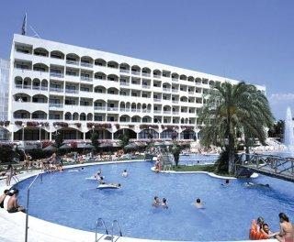
Receptionist in Costa Brava
WHERE? Girona, Costa Brava, Spain
WHEN? Position available from June/July
DURATION: minimum 3 months
HOW MANY HOURS? Full-time, 40h/week
Before you start recruitment process, please check with your school if they would accept UNIVERSITY AGREEMENT which needs to be signed at the end of recruitment process.

The tasks:
- Customer Service at Arrival, Departure and during the guests stay
- Check in / Check out, allocation of rooms
- Planning and organizing for unpredicted changes: late check-out, extensions, early departures etc.
- Giving information to hotel guests regarding tourist attraction, leisure activities
- Answering questions regarding hotel offers, facilities and events
- Taking and handling complaints, suggestions, etc.
- Further administrative tasks

We are looking for:
- Studies: Philology, Administration, Tourism etc.
- Languages: HIGH ENGLISH + HIGH SPANISH

We offer:
- Remuneration: 200€/month + meals + accommodation
- Interesting tasks, international and pleasant work environment
APPLY NOW! Please send us your CV in English or Spanish to
interns@ies-consulting.es with the title ReceptionCostaBrava

* Our recruitment process is free. Only if you get accepted and the company confirms your application, we will require an administration fee. All our internships provide salary, so we guarantee that costs of the service will pay off.

